Yum and DNF Package Management
Yum and DNF are package managers for RHEL, CentOS, and Fedora systems. They allow users and system administrators to easily install, update, remove, and query software packages.
Yum and DNF are same

Basic Commands

Install a package
# yum install <package>
# dnf install <package>
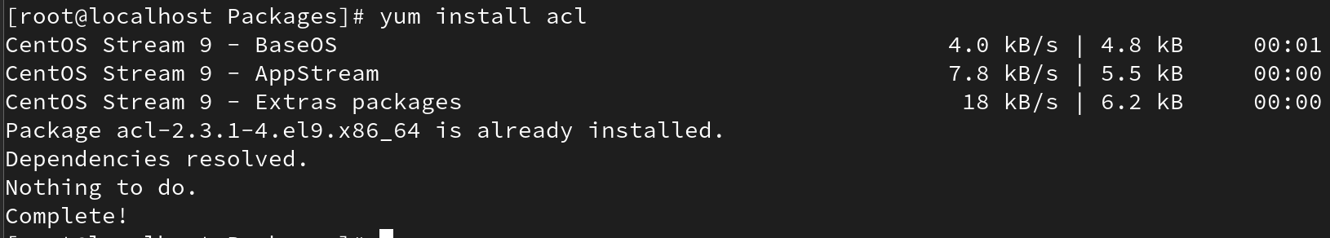

Install multiple packages
# yum install <pkg1> <pkg2> …
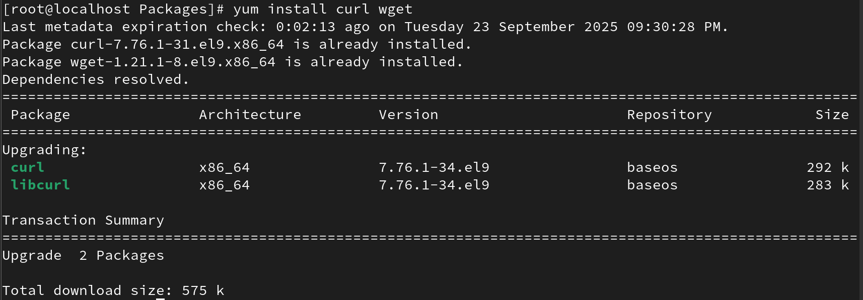

Remove a package
# yum remove <package>
# dnf remove <package>
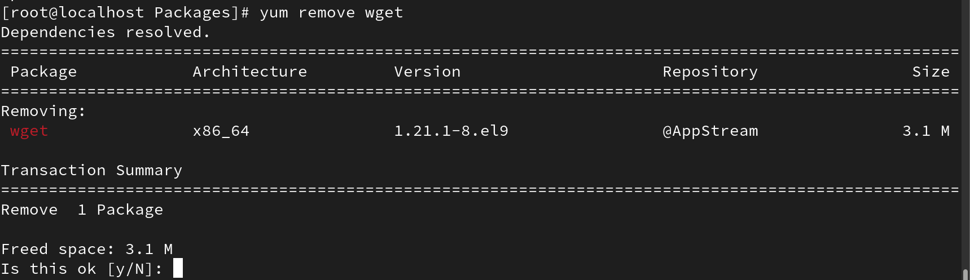

Install without confirmation
# yum install <package> -y
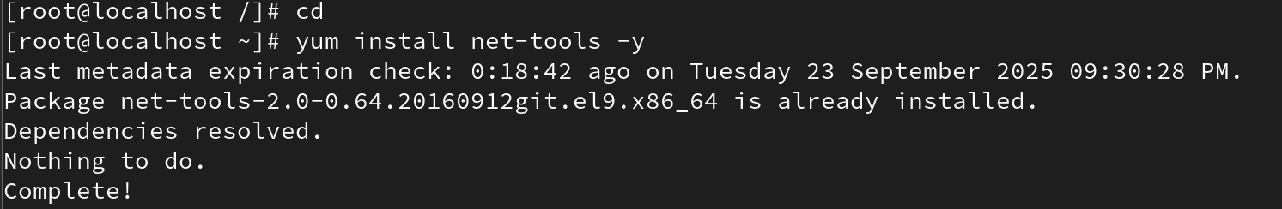

List a package
# yum list <package>

Update a package
# yum update <package>
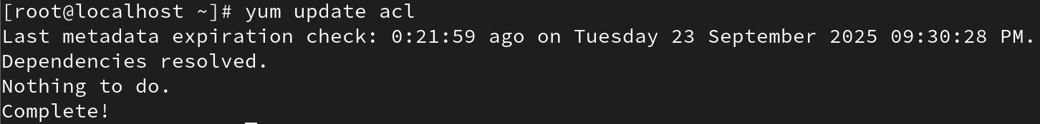

Search a package
# yum search <package>
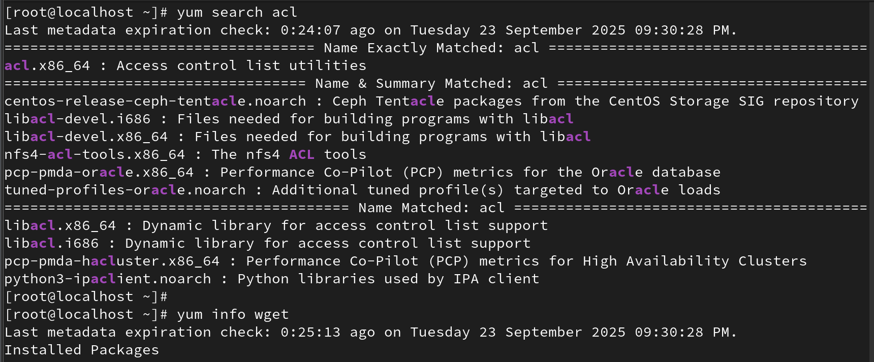
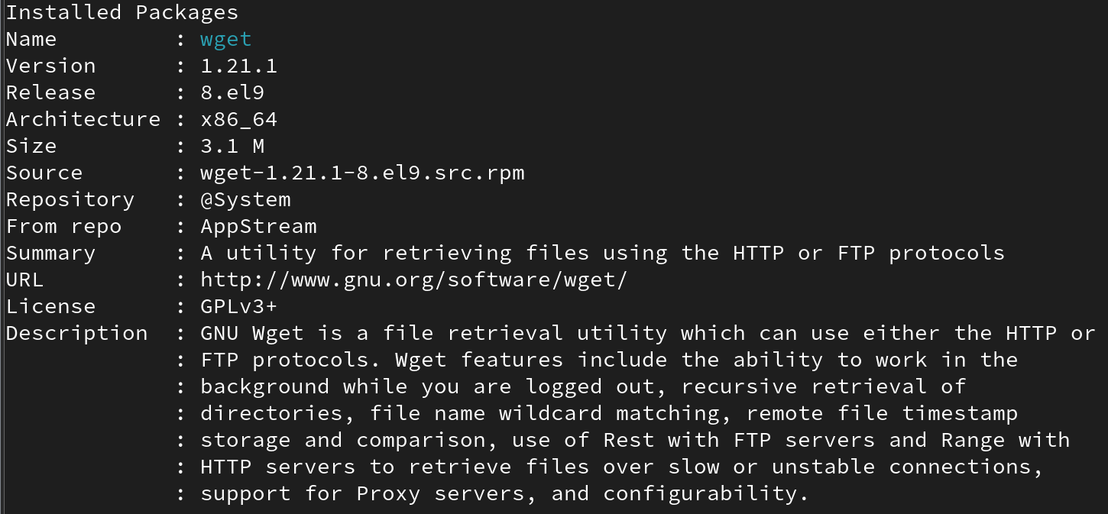

View package info
# yum info <package>
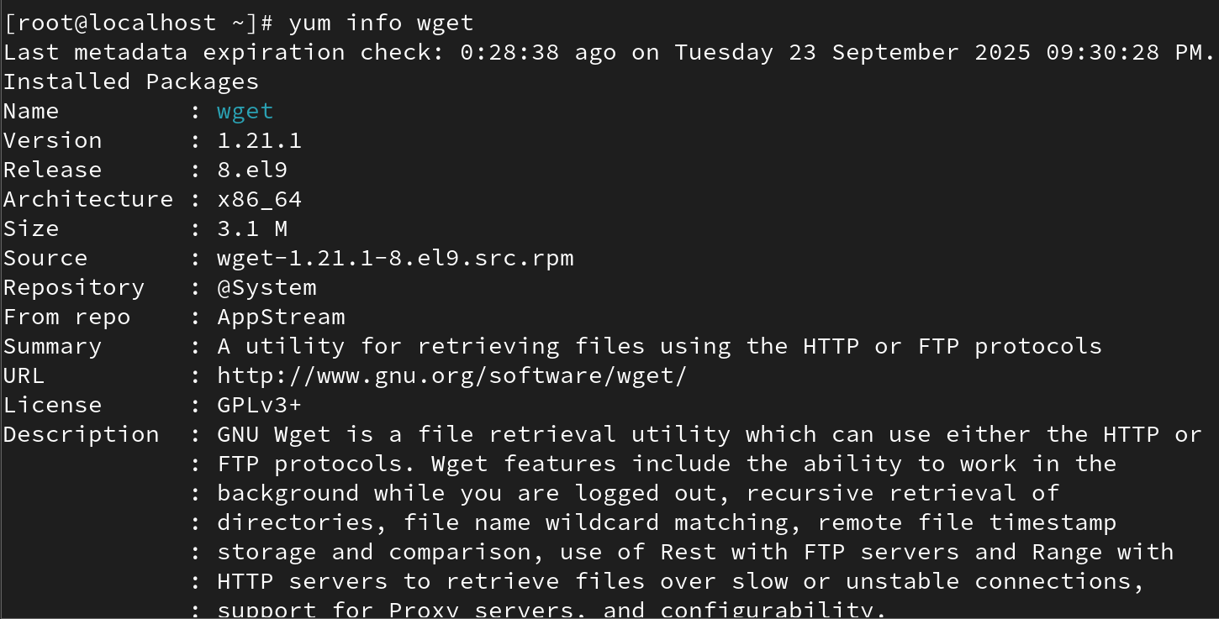

View available packages
# yum list
(yum list | less)
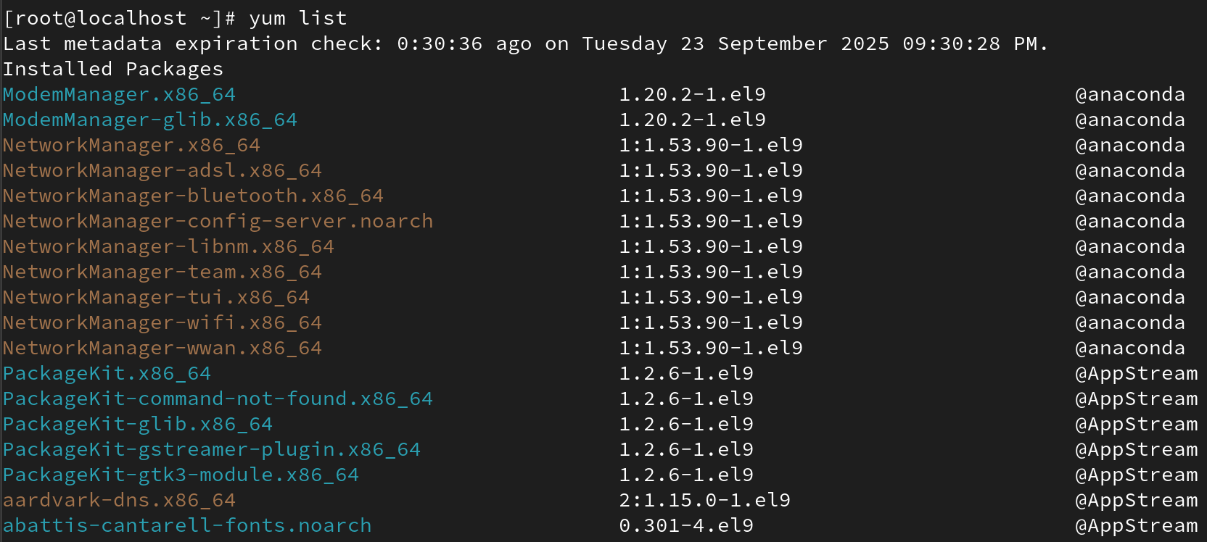

View installed packages
# yum list installed
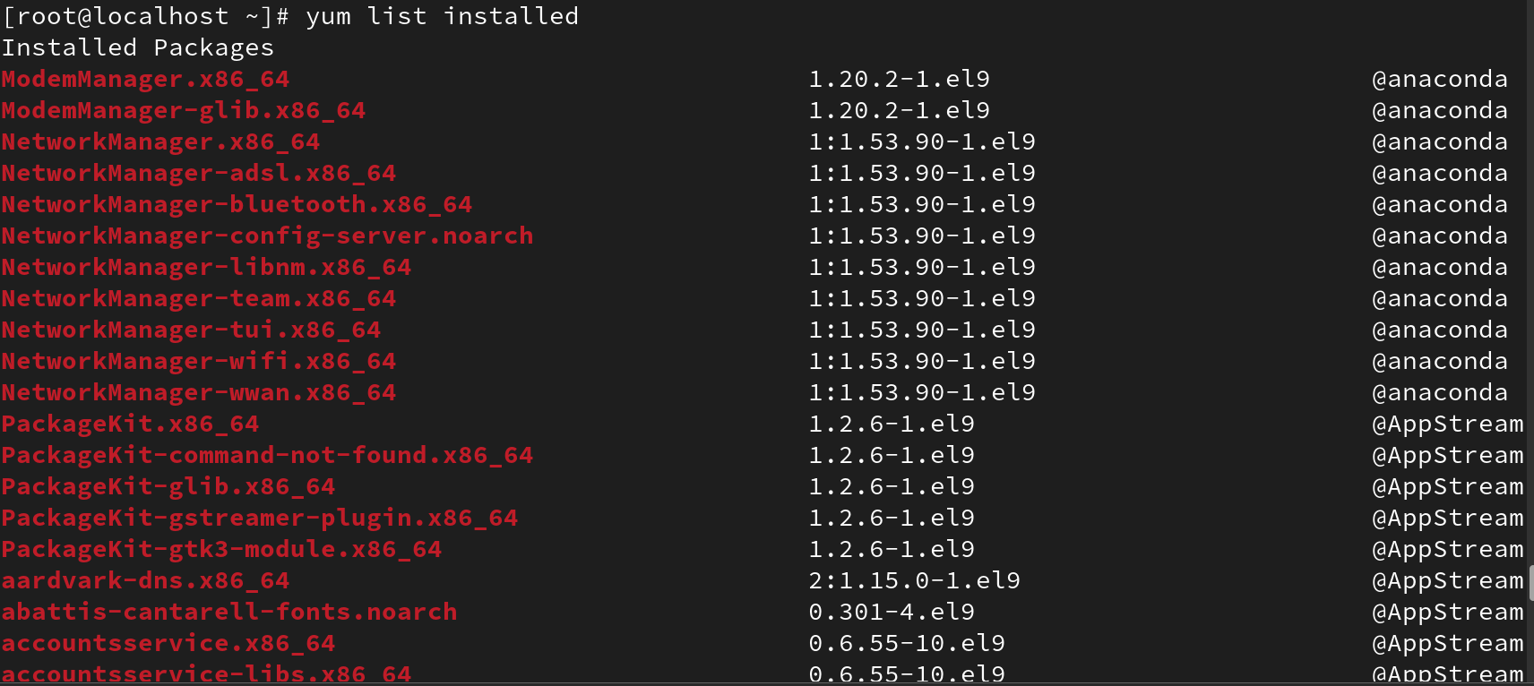

Find package providing a file
# yum provides /usr/bin/mkdir
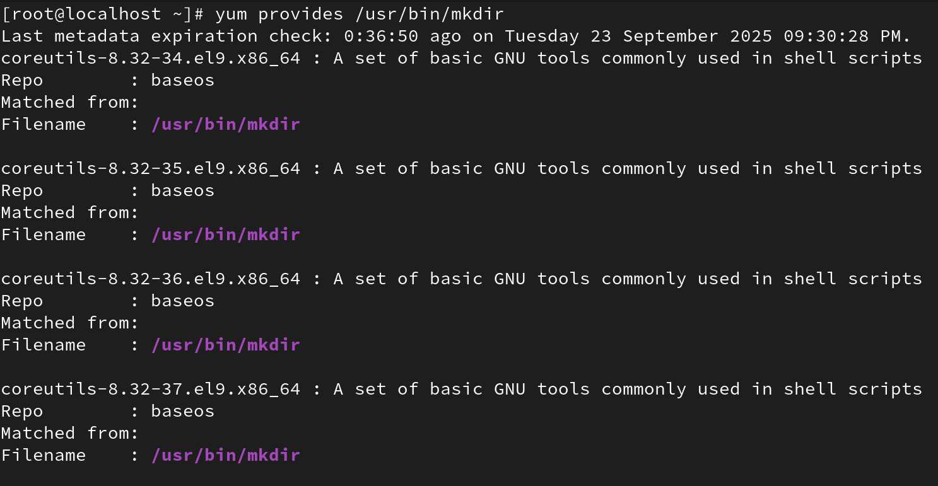
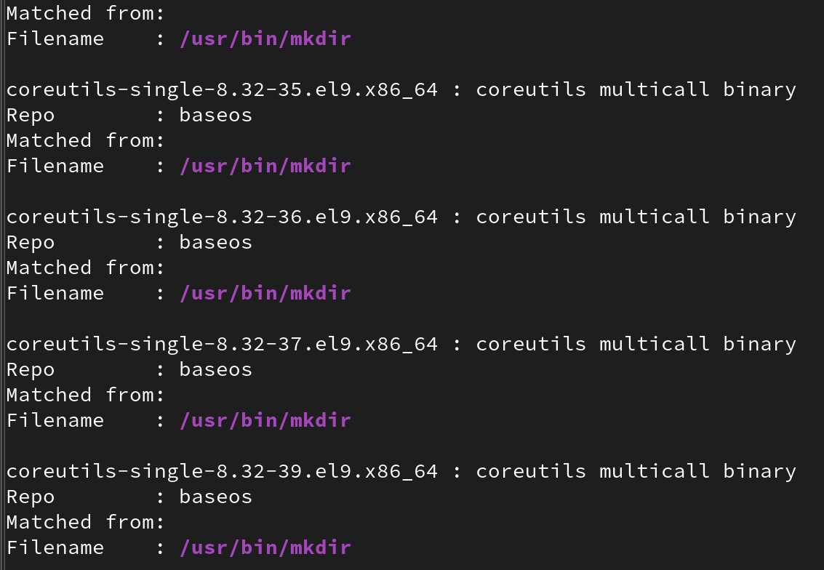

Check updates
# yum check-update
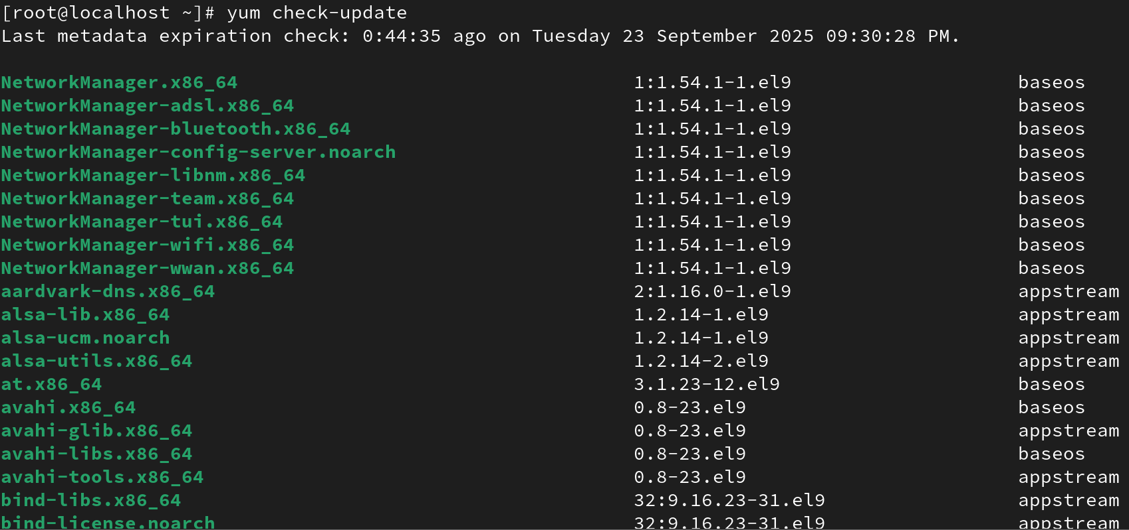

Update all packages
# yum update
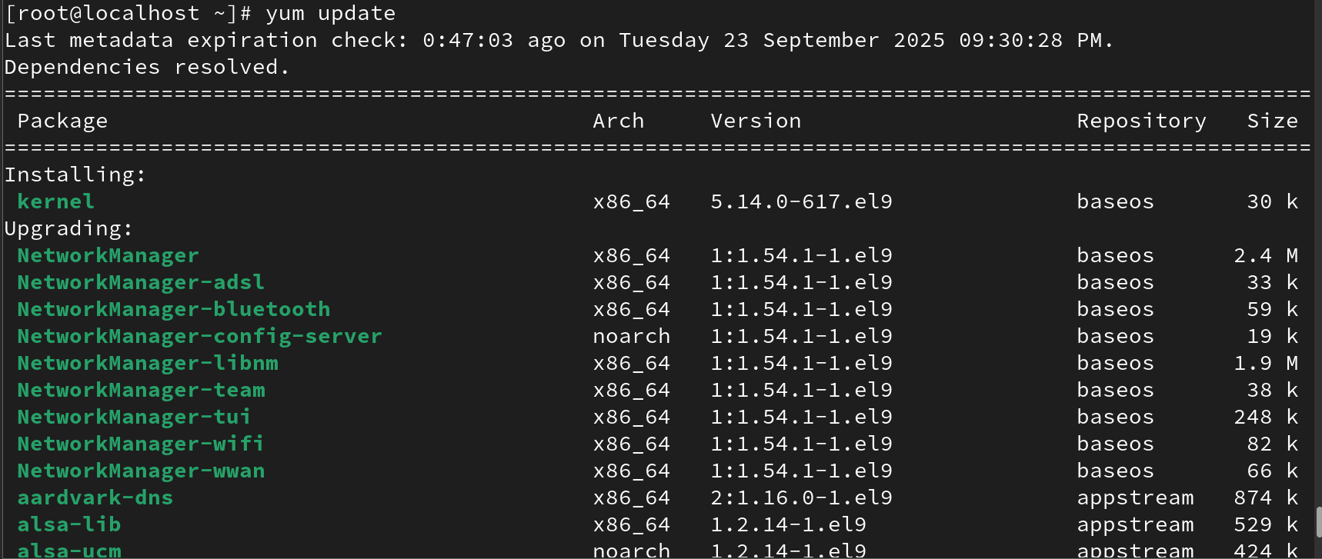
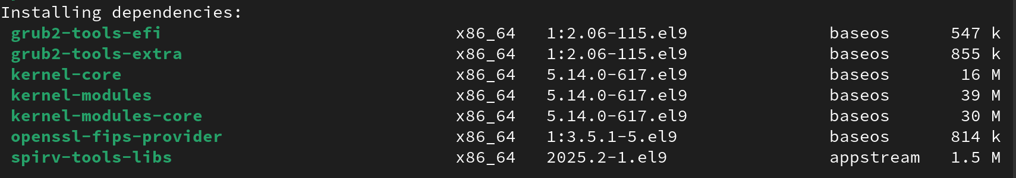

View repositories
# yum repolist
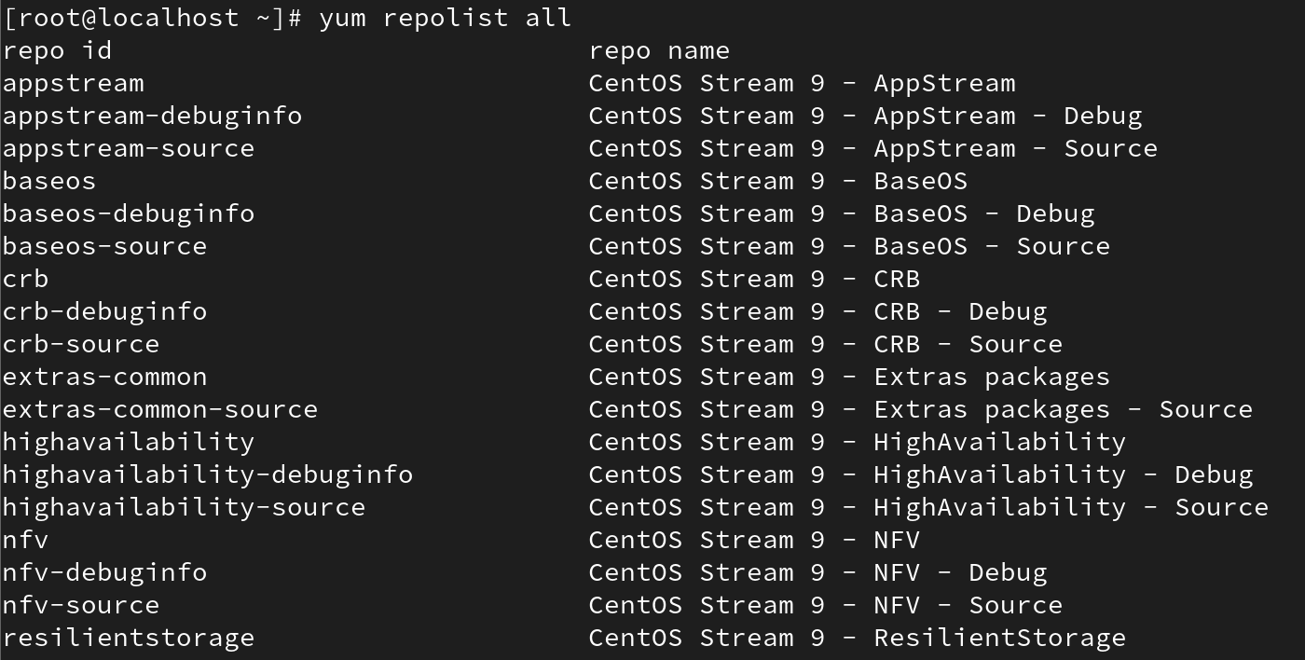
# yum repolist all
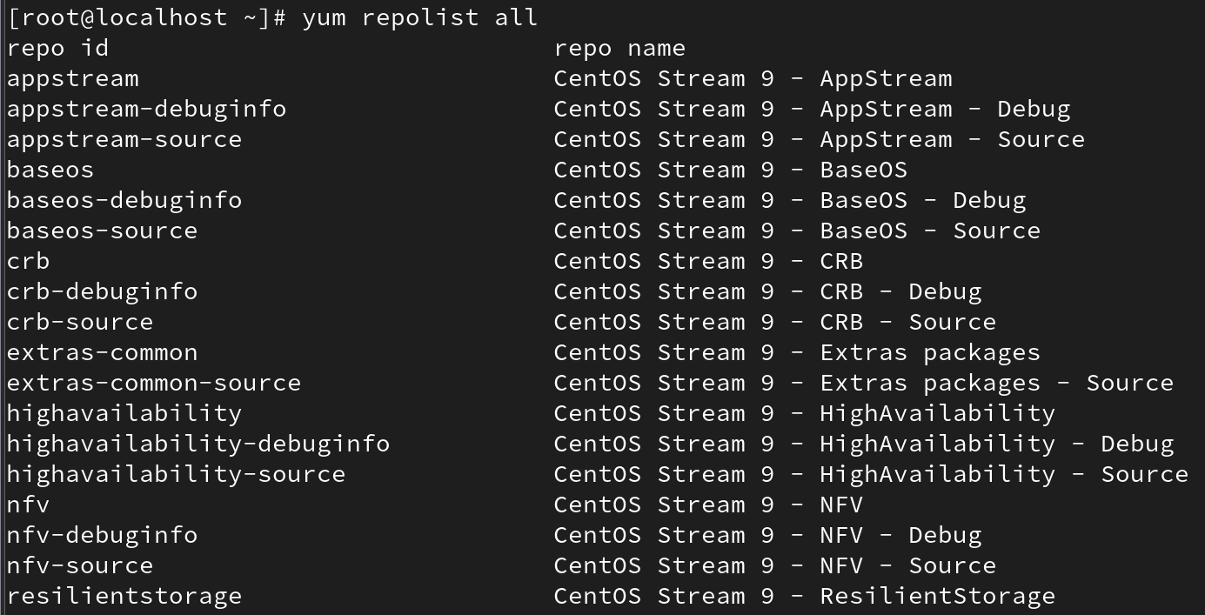

Enable repository
# yum-config-manager --enable <repo>
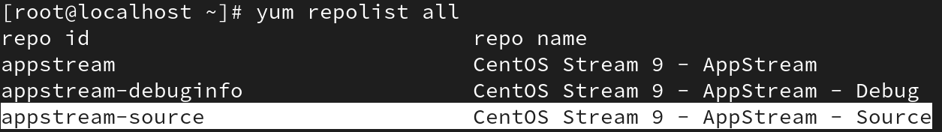

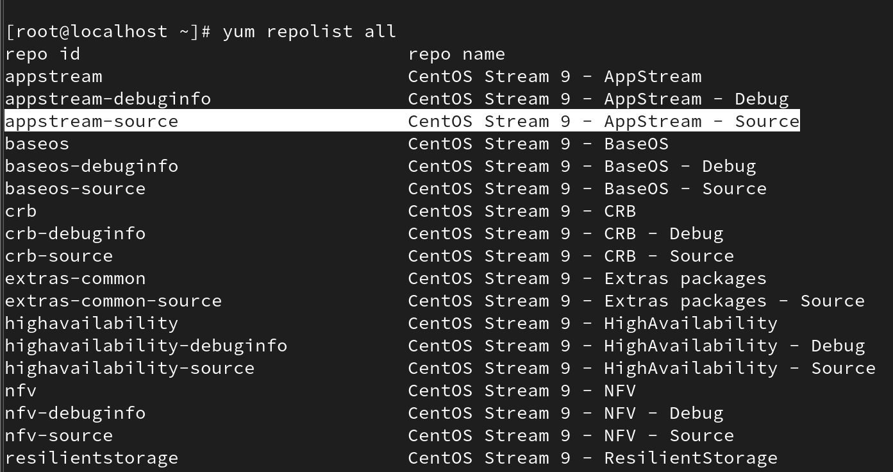

Disable repository
# yum-config-manager --disable <repo>
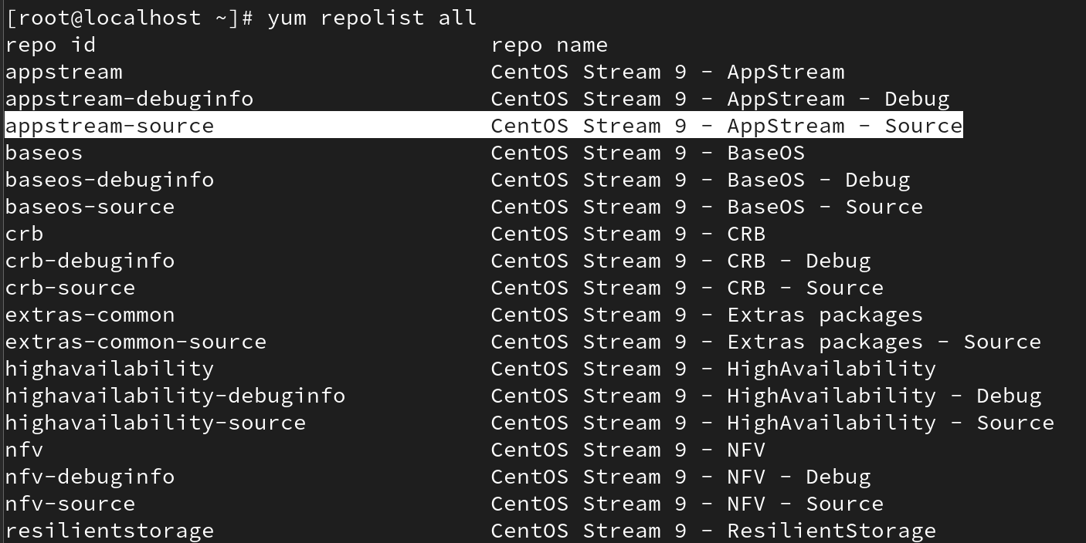

View history
# yum history
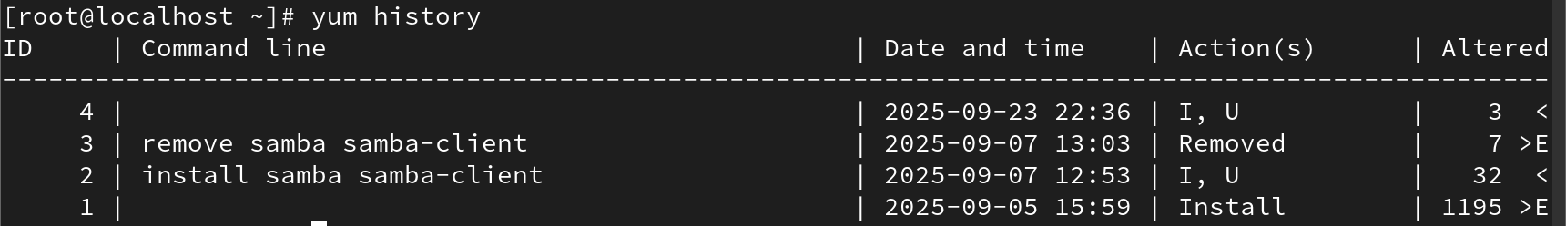

Undo a history transaction
# yum history undo <ID>
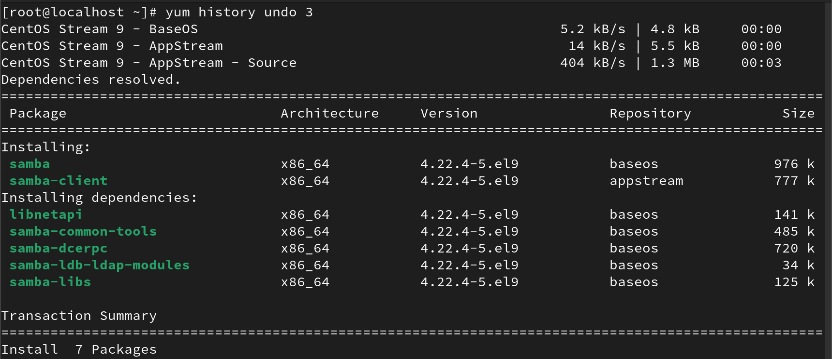

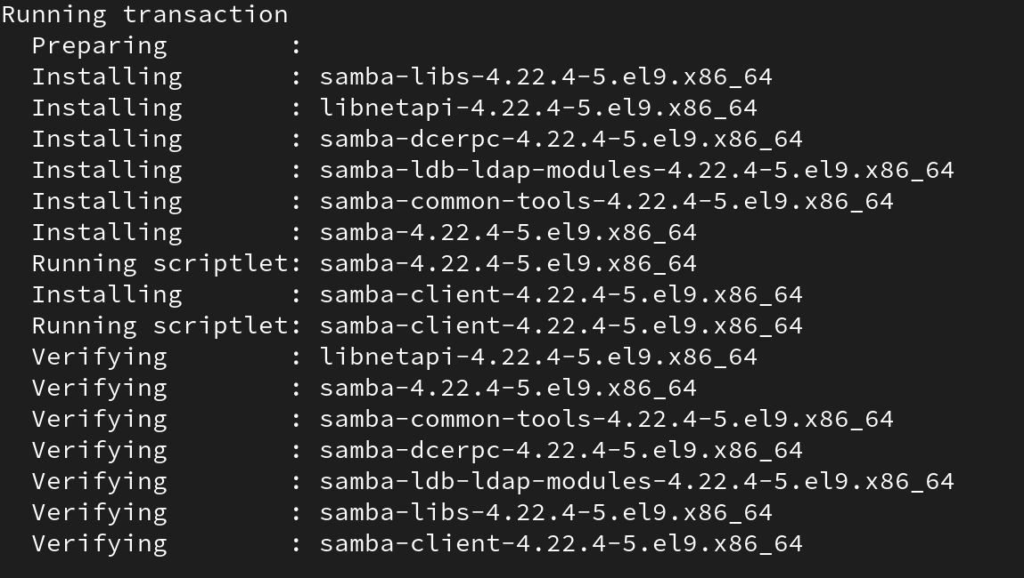

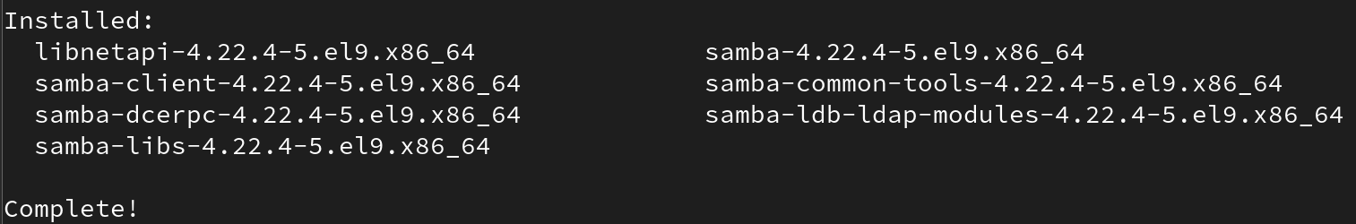

Redo a history transaction
# yum history redo <ID>
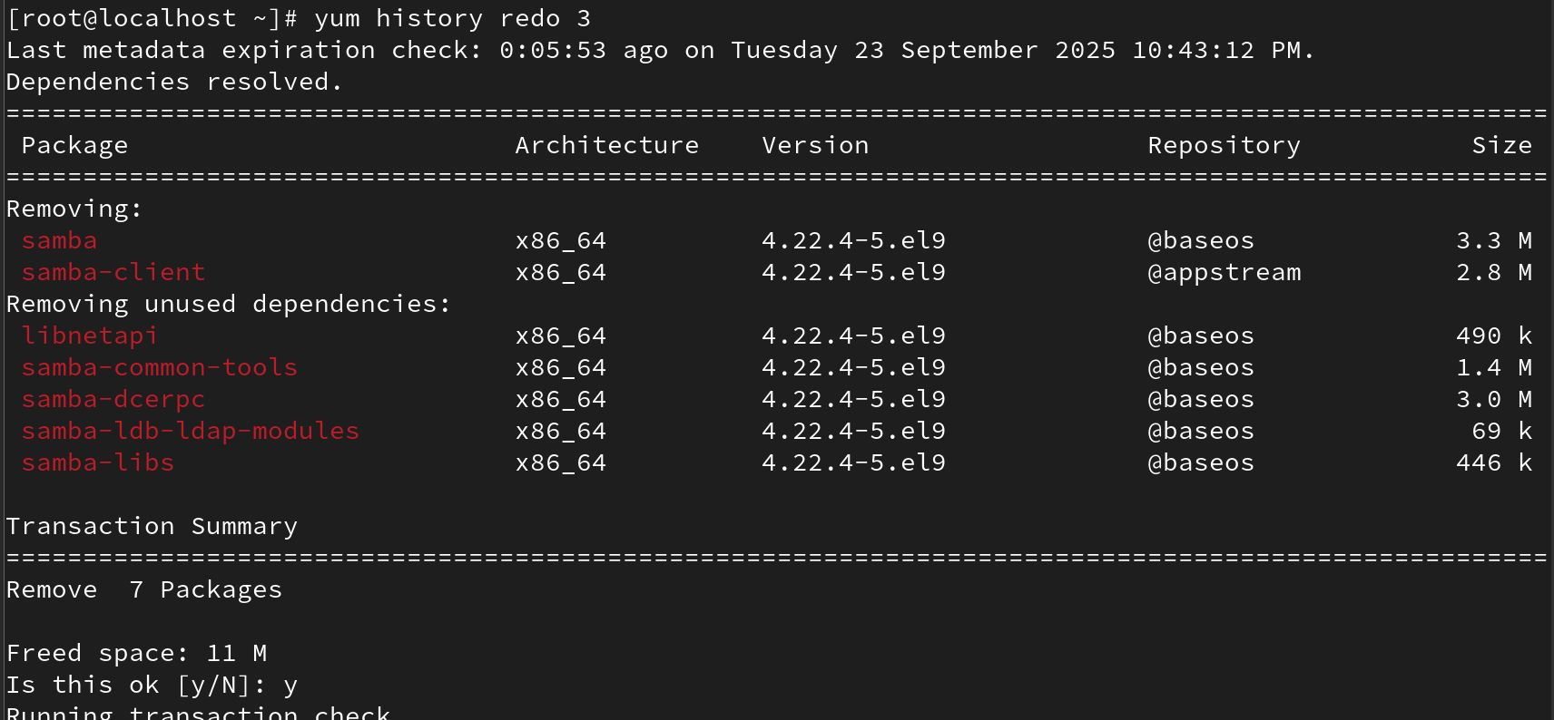
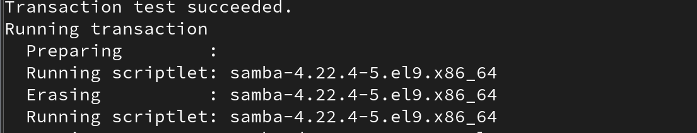

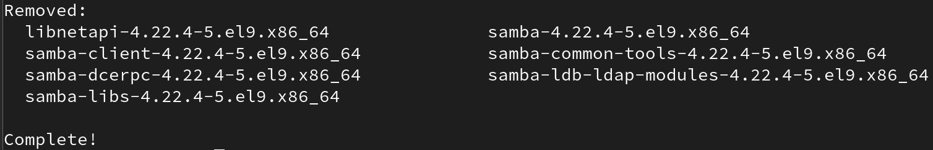

Clean cache
# yum clean all
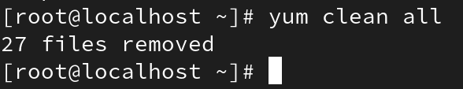

Install specific package from repo
# yum --enablerepo=<repo> install <package>
